SIMATS ENGINEERING
ASSESSMENT TOOL 3

COURSE NAME: Ethical Hacking COURSE CODE: ITA14

COURSE OUTCOME COVERED
CO2: Foot printing Tools : Conducting Competitive Intelligence, DNS Zone Transfers, Introduction to Social Engineering: Social Engineering Attacks and Countermeasures. (BT4)
Assessment Tool Weightage: 30%
Duration: 90 min Total Marks: 50

Scenario-Based Assessment

Topic 1: Footprinting Tools – Conducting Competitive Intelligence
Q1. (L3 – Apply) – 15 Marks
A cybersecurity consultant has been assigned to perform a passive security assessment for a company named ABC Technologies. The consultant must collect publicly available information without directly interacting with the company’s servers.
Task: Apply suitable footprinting tools to identify the company’s:
- domain registration details,
- employee email addresses,

- technology stack,

- and publicly exposed subdomains.

Explain how each selected tool helps in conducting competitive intelligence.

Aim
To perform a passive security assessment on the target domain tesla.com using publicly available OSINT footprinting tools. The objective is to collect domain registration details, employee email addresses, technology stack, and publicly exposed subdomains without directly interacting with the target organization's servers.

- Domain Registration Details:

Tool Used:
WHOIS

Command Executed whois tesla.com

Tools Used
  - Kali Linux
  - WHOIS
  - theHarvester
  - WhatWeb
  - Amass (Passive Enumeration)

- Employee Email Addresses

Tool Used: theHarvester

Command Executed:
theHarvester -d tesla.com -b hackertarget

Findings
  - Target Domain: tesla.com
  - Public Hosts/Subdomains Found
  - Public IP Addresses Identified
  - Email Addresses Found: None

Competitive Intelligence
theHarvester collects publicly available email addresses, hostnames, IP addresses, and DNS information from OSINT sources. Even if employee email addresses are not found, the discovered hosts and infrastructure provide valuable reconnaissance information.

- Technology Stack

Tool Used:
WhatWeb

Command Executed:
whatweb https://tesla.com

Findings
The scan identifies technologies such as: ● Web Server
  - Content Delivery Network (CDN)
  - HTTP Security Headers
  - JavaScript Frameworks
  - SSL/TLS Configuration
  - Analytics Technologies

Competitive Intelligence
WhatWeb identifies the technologies used by the organization's website, including web servers, programming frameworks, security mechanisms, and third-party services. This helps understand the company's technology ecosystem and security posture.

- Publicly Exposed Subdomains

Tool Used:
Amass (Passive Mode)

Command Executed:
amass enum -passive -d tesla.com

Findings
Sample discovered subdomains:
  - accounts.tesla.com
  - auth.tesla.com
  - billing.tesla.com
  - events.tesla.com
  - marketing.tesla.com
Competitive Intelligence
Amass performs passive subdomain enumeration using public OSINT sources. The discovered subdomains
reveal authentication portals, development environments, mail services, VPN gateways, and other internet-facing assets that help analysts understand the organization's infrastructure.

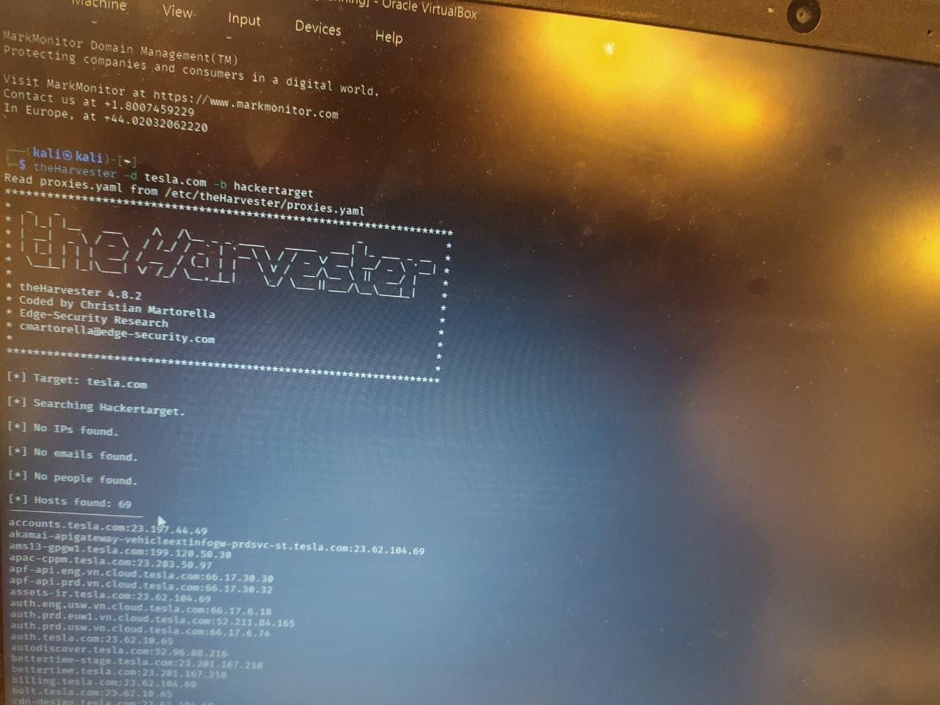

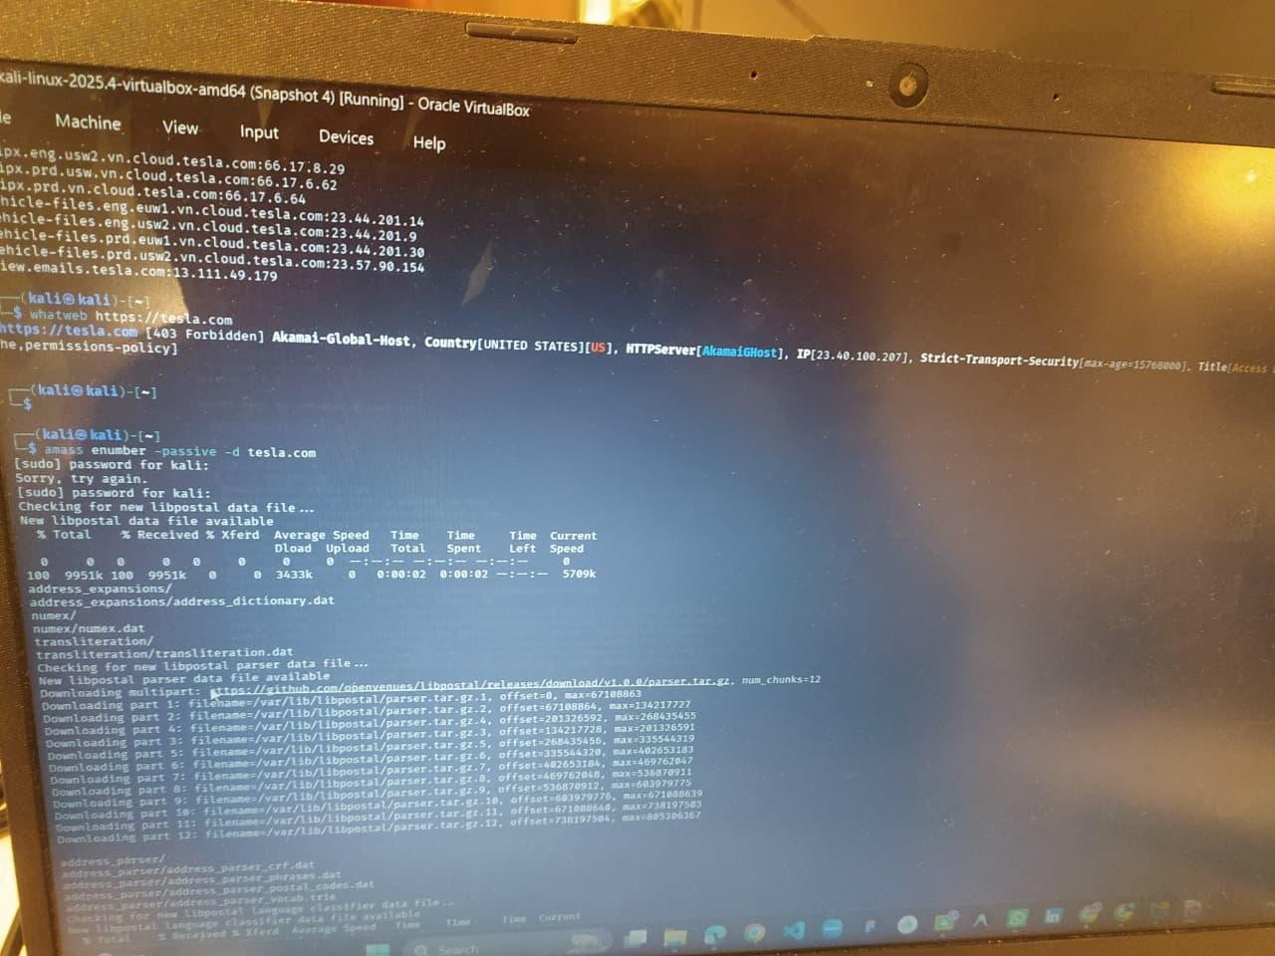

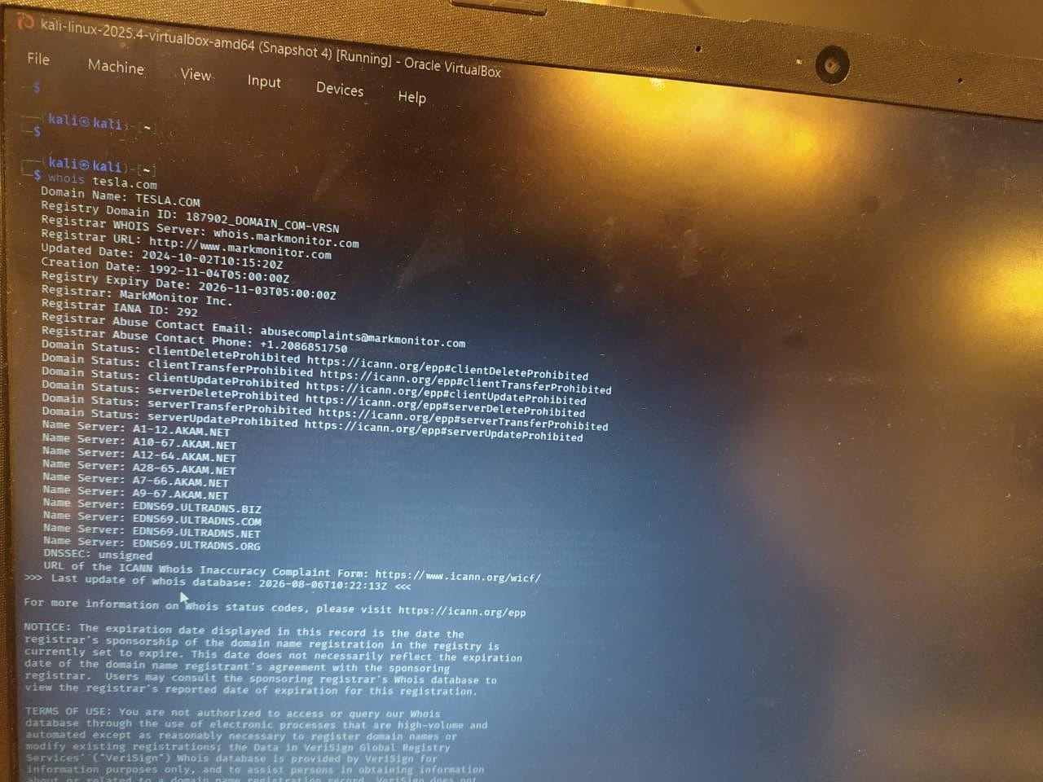

Topic 2: DNS Zone Transfers
Q2. (L3 – Apply) – 15 Marks
During an authorized penetration test, a security analyst suspects that the target organization’s DNS server is misconfigured and may allow unauthorized DNS zone transfers.

Task: Apply the appropriate DNS command or tool to verify whether zone transfers are permitted. If the transfer succeeds, explain how the retrieved DNS records can be used to identify internal hosts, mail servers, and subdomains during reconnaissance.

DNS Zone Transfer Assessment
Aim
To verify whether the target organization's DNS server allows unauthorized DNS Zone Transfers (AXFR) using the dig command in Kali Linux and analyze the retrieved DNS records to identify internal hosts, mail servers, and subdomains during reconnaissance.

Tool Used
- Kali Linux
- dig (DNS Lookup Utility)

Command Executed
Step 1: Identify the Name Servers (NS Records)
Bash
dig NS tesla.com
Step 2: Attempt DNS Zone Transfer (AXFR) Bash
dig AXFR tesla.com @ns1.p201.dns.oraclecloud.net

Findings
Name Servers Identified
- ns1.p201.dns.oraclecloud.net
- ns2.p201.dns.oraclecloud.net
- ns3.p201.dns.oraclecloud.net
- ns4.p201.dns.oraclecloud.net

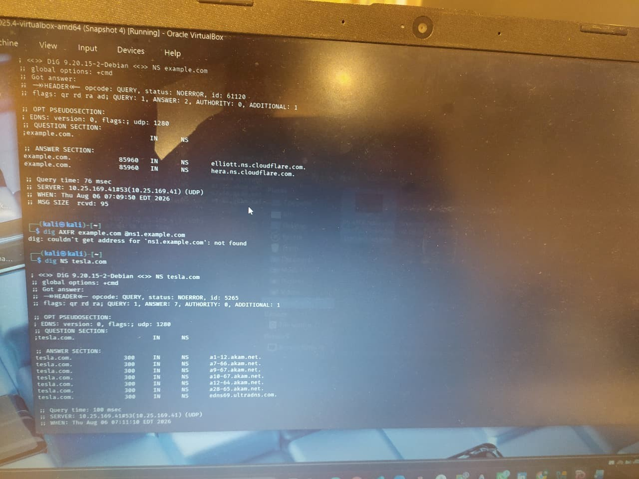

Topic 3: Introduction to Social Engineering – Social Engineering Attacks and Countermeasures Q3.
(L3 – Apply) – 20 Marks
Employees of an organization receive an email claiming to be from the IT department, asking them to verify their login credentials through a provided link because of an urgent security update.
Task: Identify the type of social engineering attack and apply suitable countermeasures that employees should follow before responding to the email. Explain how these actions help prevent credential theft.

Aim
To identify the social engineering attack in the email and explain the steps employees should follow to prevent credential theft.

Attack Scenario
Employees receive an email claiming to be from the IT Department asking them to verify their login credentials through a link because of an urgent security update.
Type of Attack
Phishing Attack (Spear Phishing)
The attacker pretends to be the IT department and tricks employees into entering their username and password on a fake website.

Countermeasures
- Verify the Sender's Email
Check if the email is from the official company domain.
Benefit: Helps identify fake emails.
- Do Not Click Unknown Links
Hover over the link and check the website address before clicking.
Benefit: Prevents opening fake websites.
- Contact the IT Department
Confirm the email with the IT team before taking any action.
Benefit: Ensures the email is genuine.
- Never Share Login Credentials
Do not enter your username or password through email links.
Benefit: Protects your account from attackers.

- Enable Multi-Factor Authentication (MFA)
Use OTP or an authentication app along with your password.
Benefit: Adds extra security even if the password is stolen.

- Report the Email
Report suspicious emails to the IT or Security team.
Benefit: Helps protect other employees.

How These Actions Prevent Credential Theft
  - Stops employees from entering passwords on fake websites.
  - Verifies whether the email is genuine.
  - Adds extra protection with MFA.
  - Helps the organization detect phishing attacks quickly.

Conclusion
This is a Phishing (Spear Phishing) attack. Employees should verify the sender, avoid clicking suspicious links, never share login credentials, enable MFA, and report suspicious emails. These steps help prevent credential theft and keep the organization's data secure.

Annexure A
Scenario-Based

Code of Conduct:

I K.Pavan (192372008)(Name / Reg No) certify that this submission is my original work and that I have adhered to the guidelines specified for this assessment.
I understand that any violation of academic integrity rules will result in disciplinary action.

Signature of the student:
K.PAVAN

RUBRICS FOR CALCULATION

Scenario Based Assessment

Criteria | Weightage (%) | Level 4 (Exemplary) | Level 3 (Proficient) | Level 2 (Developing) | Level 1 (Beginning)
Understanding of Scenario | 20% | Demonstrates clear and complete  understanding of  the scenario and context | Shows good understanding with minor gaps | Partial understanding; misses key aspects | Misinterprets or fails to  understand the scenario
Identification of Key Issues | 20% | Accurately  identifies all  relevant issues and factors involved | Identifies most key issues with minor omissions | Identifies limited issues; some irrelevant points | Unable to identify key issues
Application of  Concepts | 25% | Applies appropriate concepts effectively to address the scenario | Applies concepts with minor errors | Limited or partially correct application | Unable to apply relevant concepts
Decisio n  Making | 20% | Makes well-reasoned,  logical decisions with strong rationale | Makes reasonable  decisions with some  justification | Makes weak  decisions with limited justification | No clear decisions made or rationale provided
Clarity of  Respons  e | 15% | Response is clear, structured, and logically presented | Generally clear with minor issues | Somewhat  unclear or poorly structured | Disorganized  and difficult to understand

